**MODULE 3 – Introduction to Business Of EV**

**3.5 Summary**

Final Module Quiz

**Questions for Section 3.1**

### Question 1 A truck with single driver is transporting goods from Rome to Berlin. The total distance to be travelled is 1500 kilometers. In Europe there is driving time and resting period regulation. This demands that a truck chauffeur, may drive a maximum distance of 360 km, after that he or she must rest for three quarters of an hour. Assume that the average speed that chauffeur drives is 80 km/hr.

How long will it take for the truck to reach Berlin?

1. 21.75 hours
2. 20.0 hours
3. 22.25 hours

Ans. A

### Question 2

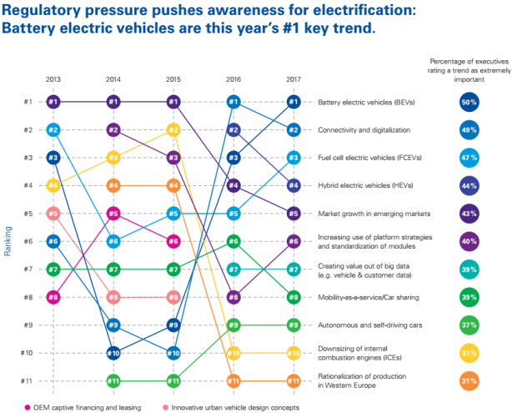

In the above figure, what are the top four trends seen as extremely important by the executives in 2017?

1. Mobility as a Service, Autonomous and self-driving cars, Battery electric vehicles, Car sharing
2. Battery electric vehicles, Connectivity and Digitalization, Fuel cell electric vehicles, Hybrid electric vehicles
3. Battery electric vehicles, Car sharing, Renewable energy, Connectivity and Digitalization

Ans. B

### Question 3 In the above figure, which two trends were falling out of the ranking during the period between 2013 and 2017?

1. OEM captive financing and leasing
2. Rationalization of production in Western Europe
3. Innovative urban vehicle design concepts
4. Downsizing of internal combustion engines (ICEs)

Ans. A & C

### Question 4 What are the three major technology disruptions mentioned in lecture 3.1 and their two corresponding goals?

1. 1. Electrification – Zero empty and Zero accident; 2. Automation – Zero congestion and Zero cost; 3. Connectivity – Zero emission and Zero energy.
2. 1. Electrification – Zero congestion and Zero cost; 2. Digitalization – Zero empty and Zero accident; 3. Connectivity – Zero energy and Zero emission.
3. 1. Electrification – Zero emission and Zero energy; 2. Automation – Zero congestion and Zero accident; 3. Connectivity – Zero empty and Zero cost.

Ans. C

**Questions for Section 3.2**

### Question 1 Battery electric trucks for the long haul transport are not very feasible in the short term, because of the enormous driving range that is required. In the long term, hydrogen-electric trucks like the recently shown Nicola One prototype can offer a solution. For the shorter term, research has been going on the feasibility of an active e-trailer concept.

Choose the correct option that best describes an e-trailer concept.

1. It will have two electric direct-drive motors on one of the rear axles of the trailer, along with a battery pack to store the energy. The active e-trailer will be able to provide extra propulsion and regeneration of brake energy for the whole combination.
2. An e-trailer will have only one electric direct-drive motor on one of the rear axles of the trailer, along with a battery pack to store the energy. The active e-trailer will be able to provide extra propulsion but cannot regenerate the brake energy.
3. An e-trailer will have three electric direct-drive motor on one of the rear axles of the trailer, along with a battery pack to store the energy. The active e-trailer will be able to provide regeneration of brake energy but cannot provide extra propulsion.

Ans. A

### Question 2 Please have a look at the statements A and B below.

*A. Apart from the possible climate change risk by CO2 in the atmosphere, toxic tailpipe emissions and traffic noise are an increasing threat for the air quality and livability of our urban areas.*

*B. In 1914, 2,4% of the Dutch car fleet was battery electric after initial success but lagged behind in electrification for practical reasons. The range was too limited and the batteries were too big, heavy and expensive whilst oil was far more energy dense and cheaper.*

Please indicate whether the statements A and B are True or False.

1. Both statement A and B are true
2. Statement A is true and statement B is false
3. Statement A is false and statement B is true
4. Both statement A and B are false.

Ans. A

### Question 3 What are the advantages of BEVs when it comes to electrification and emissions?

1. Tailpipe emission and engine noise of BEV’s are zero, which has an immediate positive effect on local air quality and livability. Depending on the energy source, emissions in the energy supply and manufacturing chain can be ultra-low or even zero. Electric cars are more and more seen as storage capacity for the fluctuating renewable energy and are in that respect helping the transition to sustainable energy.
2. There is an immediate negative effect on local air quality and livability as tailpipe emission and engine noise of BEV’s are zero. Be it any energy source, emissions in the energy supply and manufacturing chain can never reach zero. Electric cars are more and more seen as storage capacity for the constant renewable energy availability and are in that respect helping the transition to sustainable energy.

Ans. A

### Question 4 The following figure shows the distribution of raw energy use.

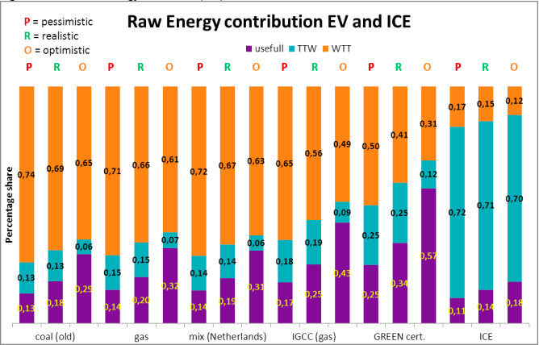

Read the statement below, then answer whether it is true or false.

*Based on the figure above, it becomes clear that even the worst-case efficiency for an EV with electricity from coal-fired utilities is still equal or better than the worst case for the ICE.*

The above statement is

1. True
2. False

Ans. A

**Questions for Section 3.3**

### Question 1 95% of accidents are now caused by humans and we saw that mobility without accidents are possible. Choose that option that best supports above description.

1. Yes, mobility without accidents is possible. Based on the SAE levels for autonomous driving, technologically we are already reach up to level 4, which means high automation.
2. No, mobility without accidents are possible. Based on the SAE levels for autonomous driving, we are only on level 2 which means partial automation.

Ans. A

### Question 2 *Braess's paradox is a proposed explanation for the situation where an alteration to a road network to improve traffic flow actually has the reverse effect and impedes traffic through it. So, when adding a road to a congested road traffic network could increase overall journey time. The paradox has also been used to explain instances of improved traffic flow when existing major roads are closed.*

Which if the following situation(s) is/are in agreement with this paradox?

1. In Seoul, South Korea, a speeding-up in traffic around the city was seen when a motorway was removed as part of the Cheonggyecheon restoration project.
2. In Stuttgart, Germany, after investments into the road network in 1969, the traffic situation did not improve until a section of newly built road was closed for traffic again.
3. In 1990 the closing of 42nd street in New York City reduced the amount of congestion in the area.
4. In 2008 Youn, Gastner and Jeong demonstrated specific routes in Boston, New York City and London where this might actually occur and pointed out roads that could be closed to reduce predicted travel times.

Ans. A, B, C & D

### Question 3 In total, there are six SAE levels of automation. It starts from no automation to full automation. There are four factors that determine these different levels of automation. Those factors are:

1. Execution of steering and acceleration/deceleration
2. Monitoring of driving environment
3. Fall back performance of dynamic driving task
4. System capability (driving modes)

How do these factors vary between partial automation and full automation?

## Option 1

### Partial automation

1. Execution of steering and acceleration/deceleration – monitored by system
2. Monitoring of driving environment - monitored by human driver
3. Fall back performance of dynamic driving task - monitored by human driver
4. System capability (driving modes) – some driving modes

### Full automation

1. execution of steering and acceleration/deceleration – monitored by system
2. Monitoring of driving environment - monitored by system
3. Fall back performance of dynamic driving task - monitored by system
4. System capability (driving modes) – All driving modes

## Option 2

### Partial automation

1. Execution of steering and acceleration/deceleration – monitored by human driver
2. Monitoring of driving environment - monitored by system
3. Fall back performance of dynamic driving task - monitored by human driver
4. System capability (driving modes) – all driving modes

### Full automation

1. execution of steering and acceleration/deceleration – monitored by human driver
2. Monitoring of driving environment - monitored by system
3. Fall back performance of dynamic driving task - monitored by system
4. System capability (driving modes) – some driving modes

Consider the two options, and state which is correct.

1. Both options 1 and 2 are correct.
2. Option 1 is correct.
3. Option 2 is correct.
4. Neither options are correct.

Ans. B

**Questions for Section 3.4**

### Question 1 Please read the following statements and answer the question:

*"Because of car sharing, a lot of private cars will become obsolete in the future."*

State if the above statement is true or false

1. True
2. False

Ans. A

### Question 2 Total cost of ownership (TCO) is a financial estimate intended to help buyers and owners determine the direct and indirect costs of a product or system. In the lecture, we saw that first prototype eco-truck for office waste, it had a lower TCO. What are the factors that help bring down TCO in the case of electric vehicles?

1. Low-emission vehicles, Low operating costs, Low fuel costs, and Savings on taxes and maintenance.
2. Low-emission vehicles, High operating costs, High fuel costs.
3. High-emission vehicles, Low operating costs, Savings on taxes and maintenance.

Ans. A

### Question 3 In the lecture from 3.4, we saw that the Electric vehicles are expected to break even by 2022. This is due to

1. Improvements in ICT and new innovative technologies.
2. The economies of scale in the battery production and supply chain for the EV parts.
3. Increase in usage of artificial intelligence and machine learning.

Ans. B

### Question 4 In the image below, we see three choices:

1. Buy new car (EV or ICE)
2. Use existing car (ICE)
3. Use mobility or Transport as a Service (TaaS)

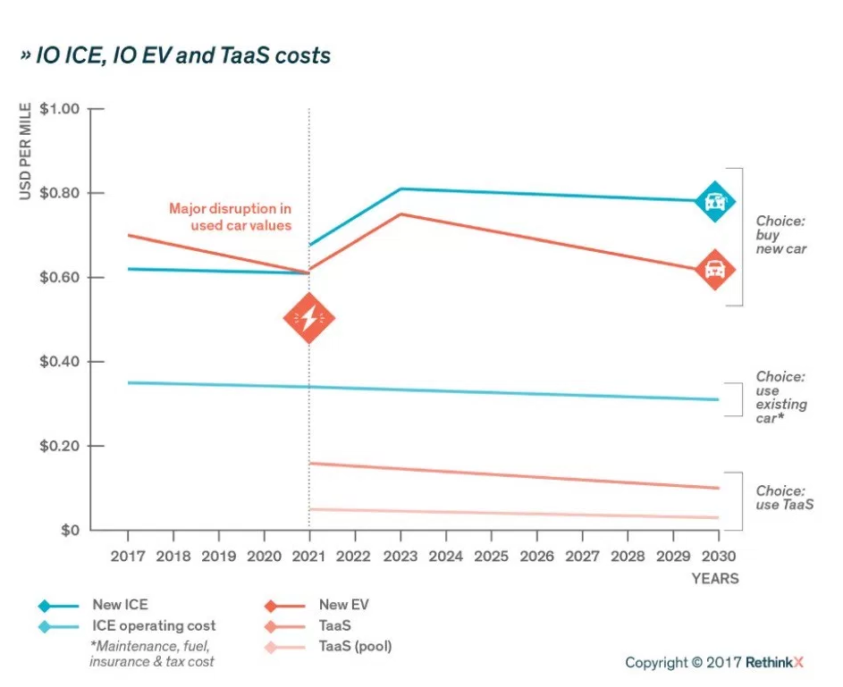

Is the choice for Transport as a Service (TaaS) the best way to move forward in the coming years?

1. Used internal combustion engine cars have costs almost about half the kilometer price, whereas an electric mobility as a service has costs of driving almost half as that of a used IC engine car. Therefore, yes, the third choice is the best way to move forward.
2. New internal combustion engine cars have costs around 0.80 USD per mile, whereas an electric mobility as a service has costs around 0.70 USD per mile. Therefore, yes, the third choice is the best way to move forward.
3. Used internal combustion engine cars have costs around 0.35 USD per mile, whereas a new EV has costs around 0.60 USD per mile. Therefore, third choice is not the best way to move forward.

Ans. A

**Questions for Section 3.5**

### Question 1 Please read the following two statements a) and b) and answer the question.

*a) European 'driving time and resting period regulation' demands that a truck chauffeur may drive only 4.5 hours maximum at a time. The maximum distance is 360km, after that he or she must rest for three quarter of an hour. This benefits the e-truck manufacturers.*

*b) In the Gartner hype-cycles, Timing and acceptance of developments are crucial for the transition to future mobility.*

Are statements a) and b) true or false?

1. Both statements are true.
2. Statement a) is true and statement b) is false.
3. Statement a) is false and statement b) is true.
4. Both statements are false

Ans. A

### Question 2 Please read the statement below and answer the question.

*According to the lecture, One-third of the energy that we need to propel an electric vehicle can be recovered while slowing down and braking. This method is called regenerative braking.*

Is the statement true or false?

1. The statement is true.
2. The statement is false.

Ans. A

### Question 3 According to the lecture, in two decades, we may achieve the Utopia of self-driving vehicles and if we do, then effects on mobility will be high. What could the effects be?

1. We will see improvements in ICT. We will see that traditional business models change mobility completely.
2. We will see increase in health and decrease in wealth. Therefore, cleaner and safer city for citizens to live in.
3. We will see mobility as a service. We will see change in insurance policies and the supply chain and logistics will also change.

Ans. C

### Question 4 Read the statements below and check the boxes of the statements you consider to be true. If you consider the statement to be false, leave the box unchecked. So, more boxes can be checked.

1. 50% of costs of a car is fixed cost. When mobility becomes a service, these costs could be distributed among many consumers and therefore driving a car becomes cheaper.
2. Connectivity will make electric mobility affordable.
3. The virtuous circle in electric mobility consists of electric vehicles, automated driving vehicles and car sharing.
4. In this course, three disruptions, electrification, mobility sharing, and connectivity have six zeros connected to it – zero emission, zero energy, zero congestion, zero accident, zero empty and zero cost.
5. The Dutch professor Sibrandus Stratingh with the scale model combined the invention of Volta and Tesla.

Ans. A, B, C, & E